IAN WILSON

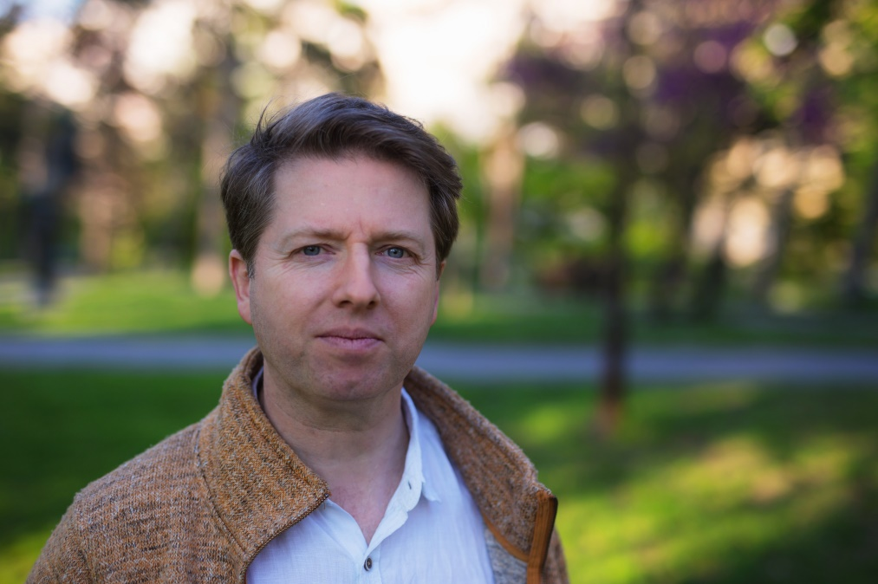

**Ian Wilson** (Northern Ireland, 1964) has composed over 250 works including operas, a range of orchestral and chamber music, and multimedia pieces.

His compositions have been performed and broadcast on six continents and presented at festivals including the BBC Proms, Venice Biennale and Gaudeamus and at venues such as New York’s Carnegie Hall, London’s Royal Albert Hall, Amsterdam’s Concertgebouw and Tokyo’s Suntory Hall. There are over 40 commercial recordings of his music available.

In 1998 he was elected to Aosdána, Ireland’s national association of creative artists, and in recent years he has been AHRB Research Fellow at the University of Ulster and “An Foras Feasa” post-Doctoral Research Fellow at Dundalk Institute of Technology as well as composer-in-association with California’s Camerata Pacifica ensemble, the Ulster Orchestra and the Hard Rain SoloistEnsemble. He was director of the Sligo New Music Festival from 2003 to 2011.

**Ian Wilson**’s music is published by **G. Ricordi & Co.** and **Universal Edition**.

Visit: [**www.ianwilson.ie**](http://www.ianwilson.ie)&[**www.soundcloud.com/wilsonkul**](http://www.soundcloud.com/wilsonkul)